**Information Available in Employee Dashboard**

On the Employee Dashboard you will see the following:

1. Your current Leave Balances
2. Link to view Full Leave Balance Information
3. Arrow to view Pay Information Links
4. Arrow to view Earnings Links
5. Arrow to view Benefits Link
6. Arrow to view Taxes Links
7. Arrow to view Job Summary Link
8. Arrow to view Employee Summary
9. My Profile button

**2 Full Leave Balance Information**

* **Click on a Leave title to view Leave Details and Prior Years Information**

* **Click on arrows to view Prior Years Leave Information**



**3 Pay Information Links**

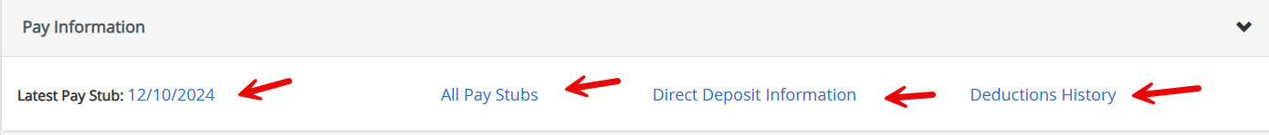

* **Latest Pay Stub –** View your latest pay stub and click the *Printer Friendly* button to print it
* **All Pay Stubs –** Select a pay year to view links to all pay stubs for that year
* **Direct Deposit Information –** View your pay distribution to your financial institutions
* **Deductions History –** View Employee Deductions and Employer Contributions to your benefits

**4 Earnings Links**

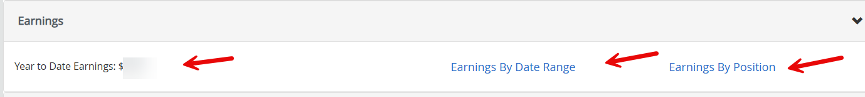

* **Year to Date Earnings –** Shows your year-to-date earnings
* **Earnings By Date Range –** Select a date range to view your earnings broken down by earnings code (salary, vacation, holiday off, etc.)
* **Earning By Positions –** Select a year or multiple years, select a position or all positions to Download a list of your earnings

**5 Benefits Links**

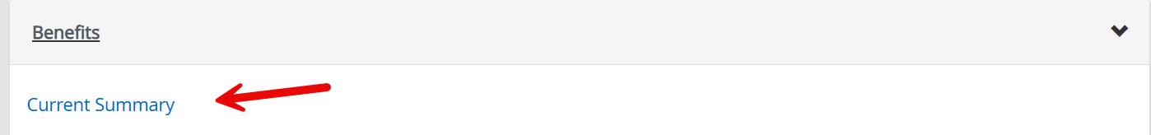

* **Current Summary –** Lists your current deductions and people covered under each deduction. Then in the Breadcrumbs at the top of the page you will see Benefit and Deductions link.

* **Benefits and Deductions –** Lists 4 groups of benefits, click on one of the group boxes, then click on the History link to see the history of a deduction, or click on the Contributions or Deductions link to see the Employee Deduction Amounts and the Employer Contribution Amounts.

**NOTE:** You will see a message “Select Add a New Benefit to add a new benefit” but there will be no benefits available for you to add.

**6 Taxes Links**

* **Federal and California W/H Tax –** A summary of your W-4 Withholding information
* **W-4 Employee’s Withholding Allowance Certificate –** With a Print button so you can print a copy
* **Electronic Regulatory Consent –** Where you can consent to receive your W-2 and your 1095-C electronically
* **1095-C Employer Provided Health Insurance Offer and Coverage Statement –** Select a year and click Display to view and print your 1095-C Statement
* **W-2 Wage and Tax Statement -** Select a year and click Display to view and print your W-2 Statement
* **W-2c Corrected Wage and Tax Statement -** Select a year and click Display to view and print your W-2 Corrected Statement (if applicable)

**7 Job Summary Link**



* **Displays Current Position**
* **Job Information –** View any changes made to your current position and changes made to your previous positions

**8 Employee Summary**

* **Summary –** Shows basic information such as your department, employee class, and hire dates

**9 My Profile Button**

* **Click on My Profile Button -** View your Address, Phone Number, Email Address, and Emergency Contact information on record with SDSU Research Foundation

**More Personal Information Link**

* **Click on the More Personal Information Link to Edit the following information:**
  + Personal Pronoun & Gender Identification
  + Phone Numbers
  + Emergency Contact Information
  + View your Ethnicity and Race
  + Veterans Classification
  + Disability Status