Assigning Schedules
Time and attendance
WorkForce Software
38705 Seven Mile Road, Ste. 300
Livonia, Michigan 48152
Phone: 734-542-4100
Fax: 734.542.0635
www.workforcesoftware.com

Assigning Temporary Schedule Templates
The process to assign a temporary schedule is identical to the process to assign permanent schedules. The only difference is that a temporary schedule will remain in effect for exactly one pay period. A permanent schedule remains in effect until it is changed or removed.

Assigning Schedule Cycles
Schedule cycles are also referred to as rotating schedules. The process is identical to the process to assign permanent schedules. The difference is you must select the phase of the rotation. For example, an employee joins a group that works a 3 week rotation. If the employee joins the group in week 2, then choose the week 2 schedule to ensure the employee is in sync with the rest of the group.

Standard Schedule Assignment
Once schedules and schedule cycles (optional, for rotating schedule needs) have been created, managers can easily assign them to individuals or to groups of employees.
- To assign either a permanent or temporary schedule template, begin by selecting Assign Schedules from the Schedules area of the dashboard. The Schedule Maintenance window appears.
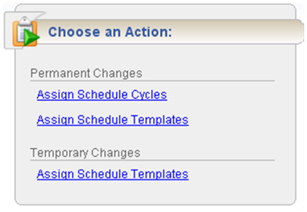
- Choose Assigning Permanent Schedule Templates or Assigning Temporary Schedule Templates.

Assigning Permanent Schedule Templates
An administrator may develop schedule templates for employees with work activities that follow a regular pattern from pay period to pay period. Managers can then assign the schedule template once and have it applied on a permanent basis to successive pay periods.
- In the Permanent Changes area of the Schedule Maintenance window, click Assign Schedule Templates.
- Select an assignment group from the assignment tree on the left. A window appears that lists the employees in the selected group.
- Select the checkbox next to the name of the employee.
(Optional) To apply the same values to more than one employee in the group, select the checkbox beside the name of each desired employee or select the checkbox at the top of the Name field to select all assignments. Make all changes in the Mass Edit section at the bottom of the window.
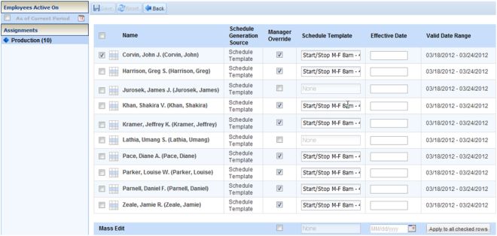
- Select the Manager Override checkbox to make the Schedule Template field active.
- From the Schedule Template drop-down list, select the correct schedule template.
- Enter the date on which to begin the schedule in the Effective Date field. The date must fall within the period defined in the Valid Date Range field.
- The recommended best practice is to select the first date in the pay period whenever possible.
- A second recommended best practice is to select the first date in the work week.
- (Optional) If making changes to more than one employee in the group, make all of the changes described in Steps 4 through 6 in the Mass Edit row at the bottom of the screen and then click Apply to all checked rows.
- After completing your permanent schedule template assignments, choose how you want to proceed.
- Click the Save icon to save your changes.
- Click the Reset icon to clear your changes and start again.
- Click the Back icon to return to the Schedule Maintenance window without saving your changes.

Assigning Schedules to Dates Outside of Current Pay Period
Managers can schedule employees for assignments to dates outside of the current pay period.
- To assign either a permanent or temporary schedule template, begin by selecting Assign Schedules from the Schedules area of the dashboard. The Schedule Maintenance window appears.
- In the Permanent Changes area of the Schedule Maintenance window, click Assign Schedule Templates.
- Click the checkbox below Employees Active On and select the week you want to assign from the calendar. The range in the Valid Date Range column at the right of the screen will change to a pay period that includes the week you’ve just selected.
- Continue as described in Steps 2 through 8 in Assigning Permanent Schedule Templates.

