Creating Time Sheet Favorites
Time sheet favorites allow you to insert a predefined time record into your time sheets or the time sheets of your employees in order to save time. Instead of entering each part of a time record every time you need to enter the information on a time sheet, you can create a favorite, which enters a combination of information all at once.
- To create a favorite on a time sheet, fill in the fields of a time record which will become a favorite.
The Time field cannot be predefined in a favorite. You must directly enter hours on the time sheet after applying a favorite.
- Click the Insert button drop-down menu on the time record from which you want to create a favorite.
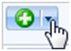
- Select Create New Favorite From Row.
- The Create Favorite window appears, listing the values of the various fields on the time record.
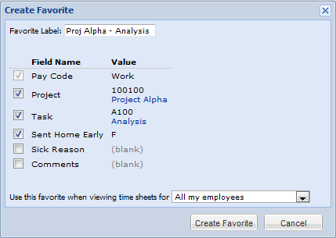
- In the Favorite Label field, enter a name for the favorite.
- The checkboxes for each part of the time record already filled out are checked by defaul. If you do not want the favorite to include a predefined value for a particular field, deselect that field by clicking the corresponding checkbox. These fields remain blank on the time record when you apply the favorite, requiring you to enter a value each time.
A pay code must always be part of a favorite, since this field is mandatory for any time record.
- In the Use this favorite when viewing time sheets for drop-down, you have a few options:
- Choose All my employees if you want to use the favorite on all of your employees’ time sheets.
- Choose All assignments in this group to make the favorite available for use on all time sheets of employees in this assignment group.
- Choose This assignment only if the favorite will only apply to this employee.
- Choose Both me and all my employees if use the favorite on all of your employees’ time sheets and on your time sheet.
- Click Create Favorite to create a favorite for the time record.
- The favorite you created appears in the Pay Code field and is available for you to use in all time sheets in the past, present, or future.
10. The favorite displays with the given label at the top of the Pay Code drop-down menu. A yellow star icon appears beside the name of the favorite.
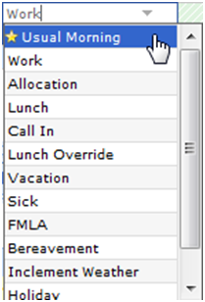
Favorites are not propagated to other users; that is, only you have access to the favorites you create. Each member of a target group/assignment has access only to favorites they have created themselves.

