Approving Time Off Requests
When an employee submits a time off request, the request is forwarded to the employee’s Supervisor for review. The Supervisor can then approve or reject the request.
- To view a listing of the time off requests that have been submitted by employees, select Schedules > Review Time Off Requests on the dashboard. The Time Off Review Summary window appears, listing pending requests, if any, and a history of past requests.
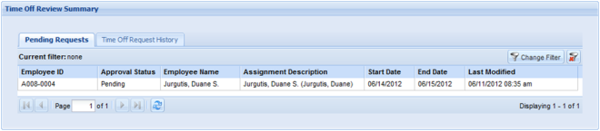
Figure 1: The Time Off Approval Summary window
- Select an employee. The request for that employee appears, including the hours requested, remaining bank balances, and history of the request.
Notice that the Request Summary window includes a link to the Group Schedule window (Open the Group Schedule), which enables you to ensure that staffing needs will be met during the time period affected by the request. The Group Schedule window also displays any other time off requests already approved.
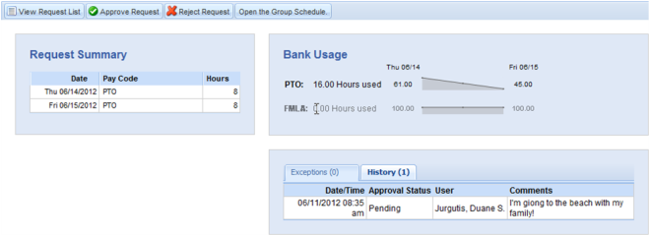
Figure 2: Request Summary window
- Use the Supervisor Comments field to forward comments about the request to the employee.
- Select Approve this Time Off Request. The Request Summary window appears again. The previous request now appears on the Time Off Request History tab.
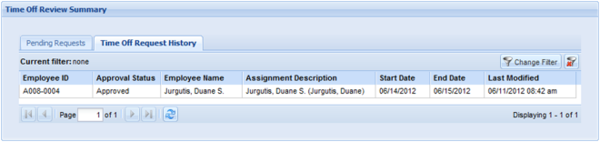
Figure 3: Request History pane

Cancelling an Approved Time Off Request
- To cancel an approved time off request, select a request from the Time Off Request History tab. The Request Summary window appears.
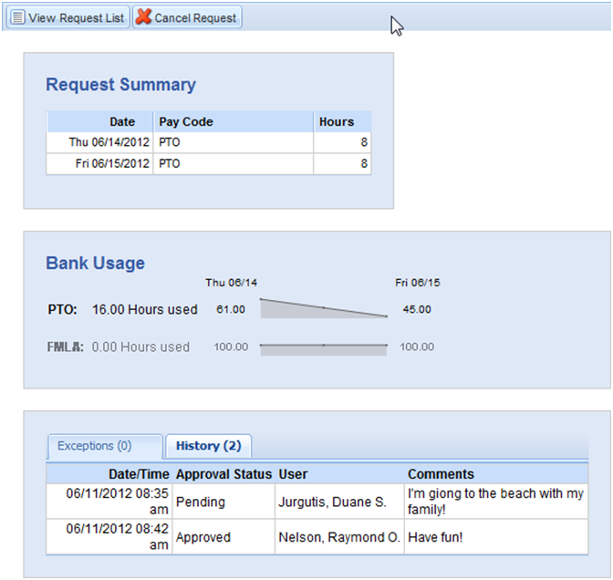
- Click Cancel Request. The Reason for Cancellation window appears.
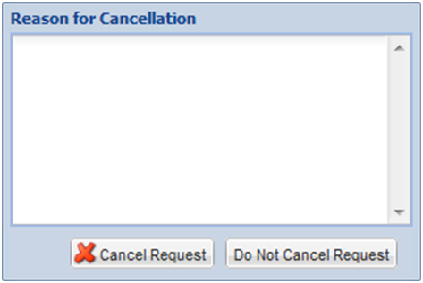
- Enter a reason for cancellation, if necessary. The cancellation is in effect after you select Cancel Request. A confirmation message displays.
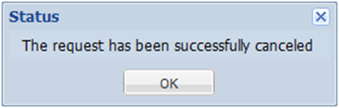
- The status of the request on the Time Off Request History tab is changed from “Approved” to “Cancelled”.
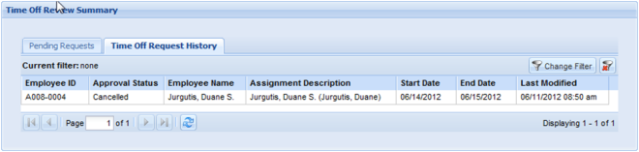
- Click the cancelled request to see a detailed history of the request.
