- Click on the Internet option on your mobile device( Safari and Chrome both work
- Go to foundation.sdsu.edu
- Click on the three bars tab above the Custom search box

- Scroll down page
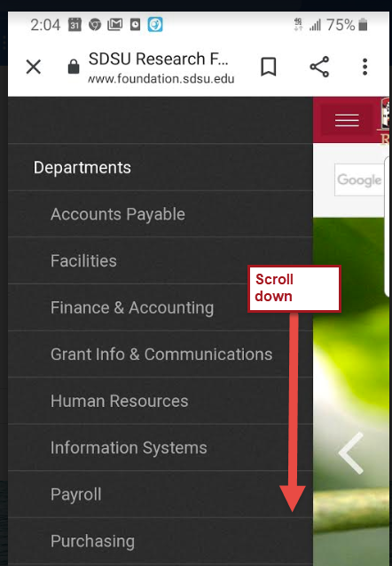
- Select Workforce (Mobile) tab
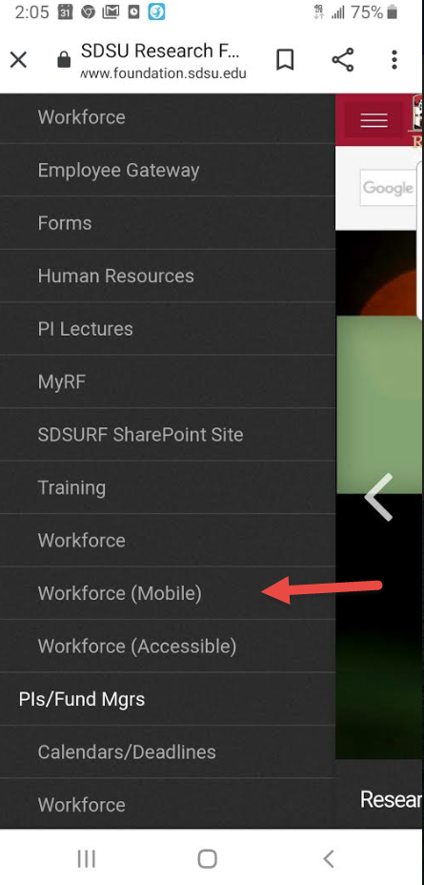

- Click on the three dots to add Workforce to your home screen
